Analysis of Gentiana data (2010)

**1. Relations between fitness components and reproductive traits - Differences in selection gradients among populations**

Linear models with type II sums of squares

Fitness components (referred to the median shoot, NOT to the whole plant): number of intact fruits (n_intact_fruits), number of mature seeds (n_seeds) 🡪 relativized to mean = 1 within each population (LokalID)

Reproductive traits: phenology index (phen_index, continuous, varies from 1 to 6, higher values indicate earlier flowering), state of the most advanced bud (most_adv, integer, varies from 1 to 6, higher values indicate earlier flowering), number of flowers (n_fl), number of shoots (n_shoots), height of the median shoot (h_shoot) 🡪 standardized to mean = 0 and sd = 1 within each population (LokalID)

Both measures of phenology (phen_index and most_adv) are strongly correlated (r = 0.86), so we have to choose one to include in the models

Response: n_intact_fruits

Sum Sq Df F value Pr(>F)

phen_index 0.7 1 0.4126 0.520742

n_fl 334.0 1 207.4691 < 2.2e-16 ***

n_shoots 3.8 1 2.3736 0.123562

h_shoot 11.2 1 6.9753 0.008329 ** Estimate: 0.12448

phen_index:LokalID 89.2 19 2.9155 2.438e-05 ***

n_fl:LokalID 138.6 19 4.5310 2.929e-10 ***

n_shoots:LokalID 37.1 19 1.2138 0.236191

h_shoot:LokalID 35.8 19 1.1706 0.273867

Residuals 3176.4 1973

Response: n_intact_fruits

Sum Sq Df F value Pr(>F)

most_adv 0.1 1 0.0476 0.82734

n_fl 296.8 1 185.1523 < 2.2e-16 ***

n_shoots 3.7 1 2.3261 0.12738

h_shoot 12.7 1 7.9045 0.00498 ** Estimate: 0.129928

most_adv:LokalID 103.4 19 3.3950 9.751e-07 ***

n_fl:LokalID 119.8 19 3.9327 2.246e-08 ***

n_shoots:LokalID 35.9 19 1.1783 0.26679

h_shoot:LokalID 37.3 19 1.2245 0.22744

Residuals 3162.8 1973

Response: n_seeds

Sum Sq Df F value Pr(>F)

phen_index 5.28 1 7.9204 0.004983 **

n_fl 121.04 1 181.6890 < 2.2e-16 ***

n_shoots 0.11 1 0.1706 0.679705

h_shoot 5.42 1 8.1400 0.004418 **

phen_index:LokalID 27.56 19 2.1773 0.002500 **

n_fl:LokalID 61.90 19 4.8902 3.853e-11 ***

n_shoots:LokalID 23.48 19 1.8547 0.014246 *

h_shoot:LokalID 27.87 19 2.2017 0.002179 **

Residuals 674.21 1012

Response: n_seeds

Sum Sq Df F value Pr(>F)

most_adv 2.06 1 3.0933 0.0789161 .

n_fl 103.64 1 155.7308 < 2.2e-16 ***

n_shoots 0.11 1 0.1587 0.6904713

h_shoot 5.57 1 8.3680 0.0039006 **

most_adv:LokalID 31.51 19 2.4917 0.0004001 ***

n_fl:LokalID 46.29 19 3.6605 2.106e-07 ***

n_shoots:LokalID 21.24 19 1.6797 0.0339156 *

h_shoot:LokalID 30.85 19 2.4401 0.0005447 ***

Residuals 673.48 1012

There are differences in selection gradients for phenology and flower number between populations, either using number of fruits or number of seeds as fitness measures. Using number of fruits, the selection for higher shoots is constant between populations. Using number of seeds, there are also differences in selection gradients for number and height of shoots.

A) Using phen_index as a measure of phenology

**2. Differences in selection gradients between populations with/without predator**

Selection gradients for each trait and population were calculated as the slope (beta-value) of the relationship between fitness and traits within that population.

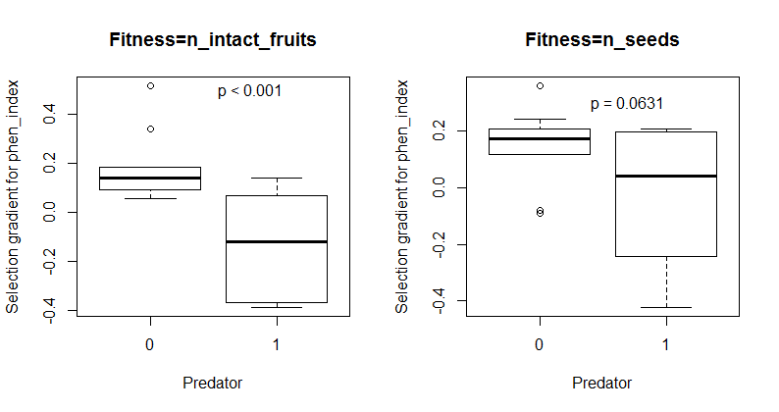

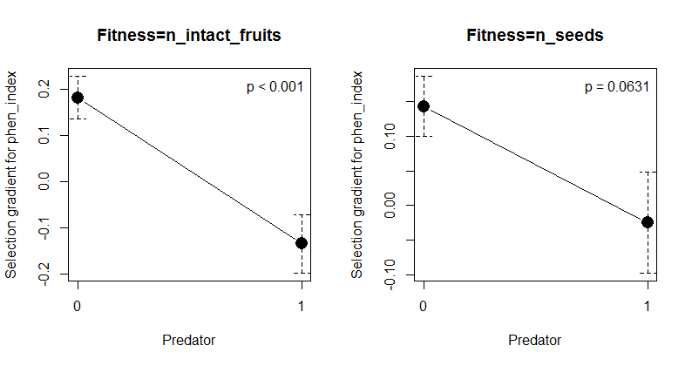

The selection gradients for phenology were different between populations with and without predator. In populations where the predator is absent there was selection for earlier flowering (higher phen_index), while in populations where the predator was present there was selection for later flowering (lower phen_index). There were not differences in selection gradients for the other traits between populations with and without predator.

**3. Variation in selection gradients with predation intensity**

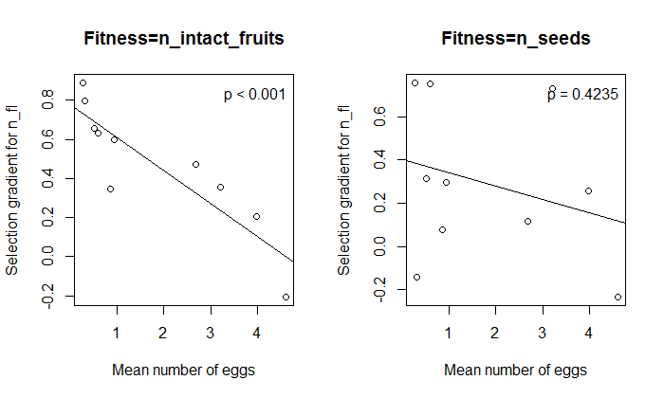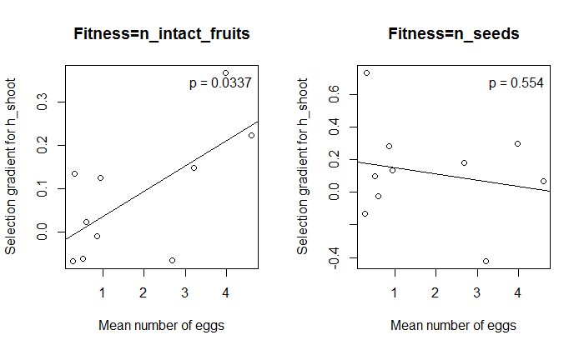

Selection gradients for flower number and shoot height are significantly related to interaction intensity measured as mean number of eggs per population (considering the 10 populations where the predator was present). This relation is significant when considering n_intact_fruits as a fitness measure, but not when considering n_seeds (maybe because seeds are counted both in intact and predated fruits?). Populations with higher intensity of predation (higher number of eggs) show selection for lower number of flowers and higher shoots (should not be the opposite, as butterflies will more easily detect higher shoots?). There is, however, no relation between intensity of predation (measured as mean number of eggs) and selection gradient for phenology.

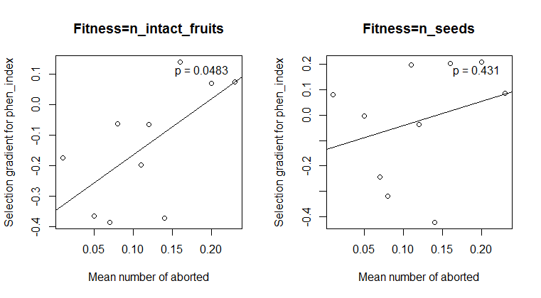

On the other hand, there is a (marginally significant) relation between intensity of predation (measured as mean number of aborted flowers, fruits and buds per population) and selection gradient for phenology. Populations with higher intensity of predation (higher number of aborted flowers, fruits and buds) show selection for earlier phenology (higher phen_index) (strange? Is number of aborted flowers, fruits and buds really a measure of predation intensity, or is abortion determined also by some other factors?). 🡪 explore this

Intensity of predation measured as mean number of predated flowers, fruits and buds did not show any significant relationship with any of the selection gradients for traits.

**4. Effects of traits on interaction intensity**

(in 10 populations where the predator is present)

Response: n_eggs

Sum Sq Df F value Pr(>F)

phen_index 490.9 1 57.5277 7.578e-14 ***

n_fl 1114.2 1 130.5807 < 2.2e-16 ***

n_shoots 9.9 1 1.1620 0.2813

h_shoot 1.6 1 0.1922 0.6612

LokalID 2576.0 9 33.5433 < 2.2e-16 ***

phen_index:LokalID 797.9 9 10.3902 1.854e-15 ***

n_fl:LokalID 1163.1 9 15.1453 < 2.2e-16 ***

n_shoots:LokalID 74.5 9 0.9700 0.4633

h_shoot:LokalID 48.6 9 0.6326 0.7698

Residuals 8567.1 1004

Response: n_pred_all

Sum Sq Df F value Pr(>F)

phen_index 8.59 1 9.7565 0.001838 ** Estimate: 0.12394

n_fl 373.20 1 424.0711 < 2.2e-16 ***

n_shoots 0.05 1 0.0599 0.806727

h_shoot 3.84 1 4.3626 0.036988 * Estimate: 0.11456

LokalID 219.11 9 27.6641 < 2.2e-16 ***

phen_index:LokalID 9.39 9 1.1860 0.300152

n_fl:LokalID 79.41 9 10.0254 7.458e-15 ***

n_shoots:LokalID 9.69 9 1.2232 0.276597

h_shoot:LokalID 12.61 9 1.5922 0.112786

Residuals 883.57 1004

Response: n_aborted_all

Sum Sq Df F value Pr(>F)

phen_index 4.720 1 34.5012 5.788e-09 ***

n_fl 3.099 1 22.6541 2.224e-06 ***

n_shoots 0.152 1 1.1125 0.291802

h_shoot 0.158 1 1.1526 0.283259

LokalID 3.288 9 2.6703 0.004575 **

phen_index:LokalID 3.659 9 2.9720 0.001698 **

n_fl:LokalID 6.020 9 4.8896 1.965e-06 ***

n_shoots:LokalID 2.560 9 2.0796 0.028731 *

h_shoot:LokalID 2.995 9 2.4328 0.009757 **

Residuals 137.342 1004

Selection on phenology and flower number seems to be in part determined by the intensity of predation.

The relationship between the number of eggs and phenology and between number of eggs and flower number varied among populations.

The relationship between the number of predated flowers, fruits and buds and flower number varied between populations. However, the relation between the number of predated flowers, fruits and buds and phenology and shoot height was consistent across populations, with more predation in plants flowering early and with higher shoots.

The relationship between the number of aborted flowers, fruits and buds and all the studied traits varied between populations.

A) Using most_adv as a measure of phenology

**2. Differences in selection gradients between populations with/without predator**

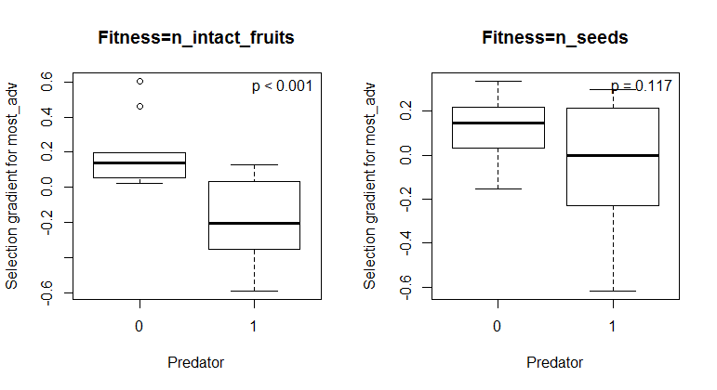 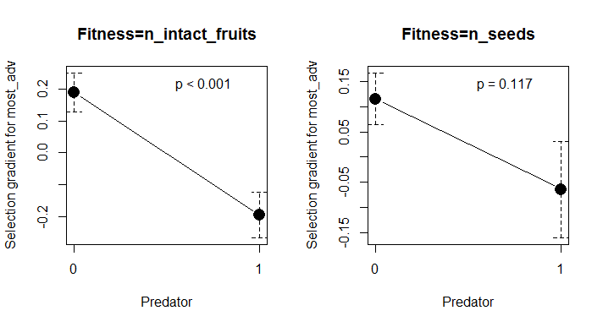

**3. Variation in selection gradients with predation intensity**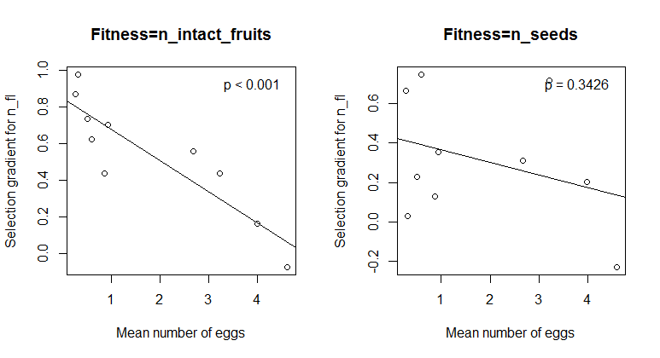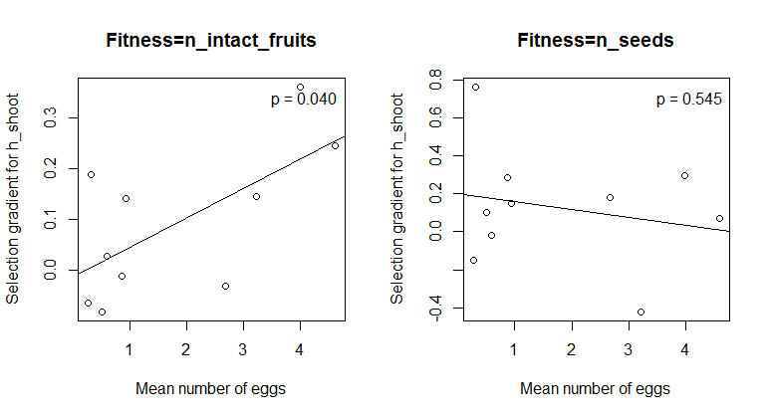 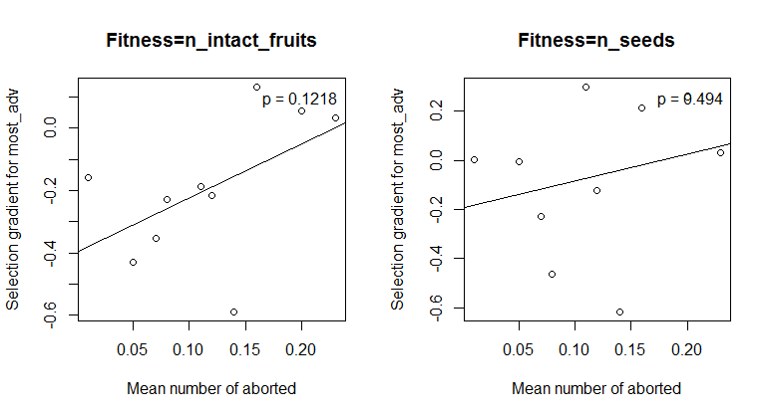

**4. Effects of traits on interaction intensity**

Response: n_eggs

Sum Sq Df F value Pr(>F)

most_adv 525.5 1 61.7037 1.023e-14 ***

n_fl 643.0 1 75.5061 < 2.2e-16 ***

n_shoots 8.8 1 1.0306 0.3103

h_shoot 0.1 1 0.0131 0.9088

LokalID 2548.8 9 33.2563 < 2.2e-16 ***

most_adv:LokalID 780.6 9 10.1849 4.057e-15 ***

n_fl:LokalID 635.3 9 8.2894 5.600e-12 ***

n_shoots:LokalID 80.6 9 1.0517 0.3965

h_shoot:LokalID 53.7 9 0.7011 0.7083

Residuals 8549.8 1004

Response: n_pred_all

Sum Sq Df F value Pr(>F)

most_adv 10.44 1 11.8112 0.0006129 ***

n_fl 308.36 1 348.7797 < 2.2e-16 ***

n_shoots 0.02 1 0.0238 0.8774268

h_shoot 3.24 1 3.6669 0.0557879 .

LokalID 216.04 9 27.1503 < 2.2e-16 ***

most_adv:LokalID 3.45 9 0.4338 0.9172326

n_fl:LokalID 69.79 9 8.7714 8.925e-13 ***

n_shoots:LokalID 10.06 9 1.2643 0.2521905

h_shoot:LokalID 10.86 9 1.3652 0.1993350

Residuals 887.65 1004

Response: n_aborted_all

Sum Sq Df F value Pr(>F)

most_adv 3.869 1 28.1114 1.408e-07 ***

n_fl 4.603 1 33.4450 9.784e-09 ***

n_shoots 0.168 1 1.2196 0.269707

h_shoot 0.146 1 1.0587 0.303758

LokalID 3.188 9 2.5741 0.006234 **

most_adv:LokalID 3.671 9 2.9639 0.001744 **

n_fl:LokalID 7.060 9 5.6999 9.858e-08 ***

n_shoots:LokalID 2.059 9 1.6621 0.093710 .

h_shoot:LokalID 3.135 9 2.5308 0.007158 **

Residuals 138.180 1004

**5. Ants 2010**

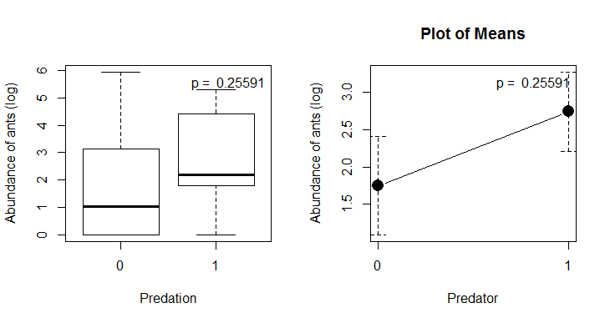

There are no significant differences in ant abundance between populations where the predator is present and absent. However, ant abundance is higher in populations where the predator is present and if we remove one outlier (a population, Mar001, with no butterflies but with high number of ants), the differences are nearly significant (see below).

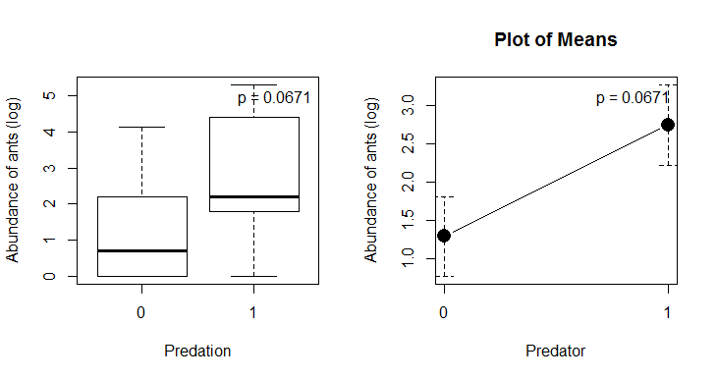

Call:

glm(formula = pred ~ log(ants + 1), family = binomial, data = ants)

Deviance Residuals:

Min 1Q Median 3Q Max

-1.67542 -1.00910 -0.04623 1.17477 1.47286

Coefficients:

Estimate Std. Error z value Pr(>|z|)

(Intercept) -0.6722 0.7345 -0.915 0.360

log(ants + 1) 0.3020 0.2599 1.162 0.245

(Dispersion parameter for binomial family taken to be 1)

Null deviance: 27.726 on 19 degrees of freedom

Residual deviance: 26.268 on 18 degrees of freedom

AIC: 30.268

Number of Fisher Scoring iterations: 4

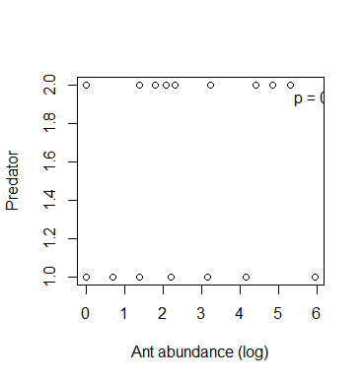

If we see it the other way round with a logistic regression, ant abundance has no effect on the presence of the butterfly.

If we remove the outlier, the effect of ant abundance on butterfly presence is marginally significant (see below).

Call:

glm(formula = pred ~ log(ants + 1), family = binomial, data = ants_sub)

Deviance Residuals:

Min 1Q Median 3Q Max

-1.7970 -0.8451 0.4856 1.0781 1.6462

Coefficients:

Estimate Std. Error z value Pr(>|z|)

(Intercept) -1.0567 0.8136 -1.299 0.1940

log(ants + 1) 0.5912 0.3413 1.732 0.0833 .

---

Signif. codes: 0 ‘***’ 0.001 ‘**’ 0.01 ‘*’ 0.05 ‘.’ 0.1 ‘ ’ 1

(Dispersion parameter for binomial family taken to be 1)

Null deviance: 26.287 on 18 degrees of freedom

Residual deviance: 22.521 on 17 degrees of freedom

AIC: 26.521

Number of Fisher Scoring iterations: 4

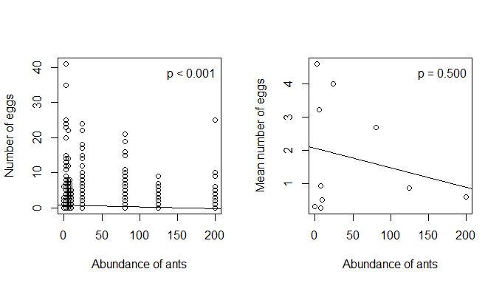

There is a slightly negative relationship between interaction intensity measured as number of eggs and ant abundance.

* Butterflies can cause declines on ant populations due to its parasitic effect, as they are fed by the colony.

Analysis of Gentiana data (2011)

Removed populations with LokalID = Mar001, Sve001, Sve005 and Sve011 because there is no information on fruits and seeds.

**1. Relations between fitness components and reproductive traits - Differences in selection gradients among populations**

Both measures of phenology (phen_index and most_adv) are strongly correlated (r = 0.82), so we have to choose one to include in the models.

In this year we should be cautious about using number of seeds as a fitness measure, because only one fruit was collected from each individual (in most of the cases), so the count of seeds depends on if this fruit was or not predated. Therefore, I think this will not give an accurate measure of the actual number of seeds per plant. We should maybe avoid using number of seeds and just keep number of intact fruits as a fitness measure for both years (as it also gives better results in 2010).

Response: n_intact_fruits

Sum Sq Df F value Pr(>F)

phen_index 6.0 1 2.4571 0.1171974

n_fl 158.9 1 64.9050 1.566e-15 ***

n_shoots 0.2 1 0.0914 0.7624052

h_shoot 0.9 1 0.3840 0.5355609

phen_index:LokalID 61.0 15 1.6616 0.0522906 .

n_fl:LokalID 91.7 15 2.4966 0.0012009 **

n_shoots:LokalID 26.7 15 0.7274 0.7584049

h_shoot:LokalID 95.0 15 2.5876 0.0007627 ***

Residuals 3751.2 1532

Response: n_intact_fruits

Sum Sq Df F value Pr(>F)

most_adv 1.2 1 0.4708 0.4927240

n_fl 119.2 1 48.7982 4.215e-12 ***

n_shoots 0.2 1 0.0643 0.7999103

h_shoot 1.1 1 0.4530 0.5009989

most_adv:LokalID 71.5 15 1.9510 0.0155600 *

n_fl:LokalID 102.1 15 2.7845 0.0002795 ***

n_shoots:LokalID 25.1 15 0.6843 0.8022097

h_shoot:LokalID 84.7 15 2.3107 0.0029717 **

Residuals 3746.2 1533

Response: n_seeds

Sum Sq Df F value Pr(>F)

phen_index 4.419 1 2.4228 0.121872

n_fl 15.549 1 8.5253 0.004092 **

n_shoots 0.418 1 0.2289 0.633082

h_shoot 6.954 1 3.8128 0.052886 . Estimate: -0.14749

phen_index:LokalID 32.182 15 1.1763 0.297147

n_fl:LokalID 95.787 15 3.5013 4.386e-05 ***

n_shoots:LokalID 25.861 15 0.9453 0.516326

h_shoot:LokalID 37.390 15 1.3667 0.172137

Residuals 251.689 138

Response: n_seeds

Sum Sq Df F value Pr(>F)

most_adv 1.076 1 0.5538 0.458031

n_fl 10.666 1 5.4876 0.020582 *

n_shoots 0.167 1 0.0860 0.769764

h_shoot 6.174 1 3.1762 0.076919 . Estimate: -0.157656

most_adv:LokalID 18.981 15 0.6510 0.827671

n_fl:LokalID 76.179 15 2.6128 0.001726 **

n_shoots:LokalID 24.218 15 0.8307 0.642290

h_shoot:LokalID 41.041 15 1.4076 0.151743

Residuals 268.233 138

There are differences in selection gradients for flower number between populations, either using number of fruits or number of seeds as fitness measures. Using number of fruits, there are differences in the selection gradient for phenology (when using phen_index the interaction is marginally significant) and shoot height. Using number of seeds, the selection for lower shoots is constant between populations (although the effect is marginally significant).

A) Using phen_index as a measure of phenology

**2. Differences in selection gradients between populations with/without predator**

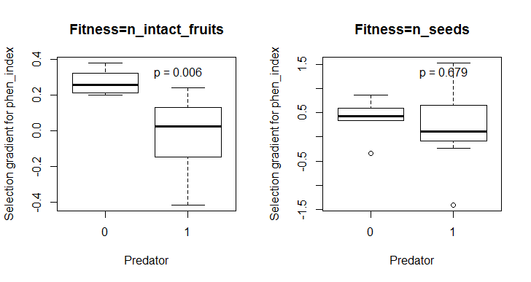

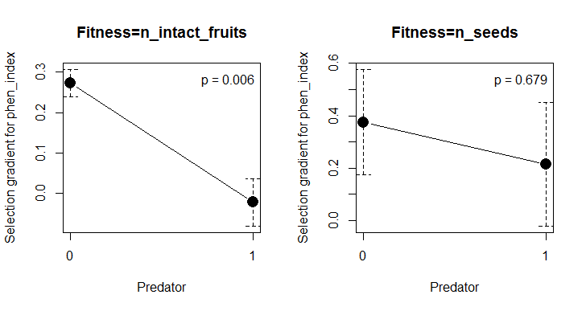

The selection gradients for phenology were different between populations with and without predator when fitness was measured as the number of intact fruits. In populations where the predator is absent there was selection for earlier flowering (higher phen_index), while in populations where the predator was present there was selection for later flowering (lower phen_index). There were no differences in selection gradients for phenology when fitness was measured as the number of seeds.

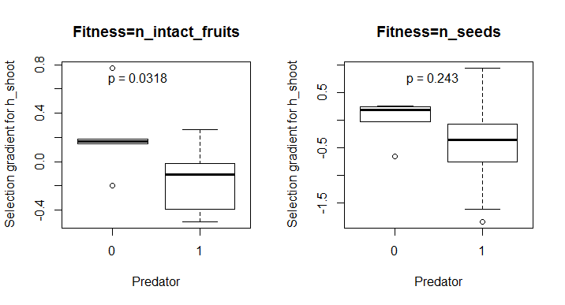

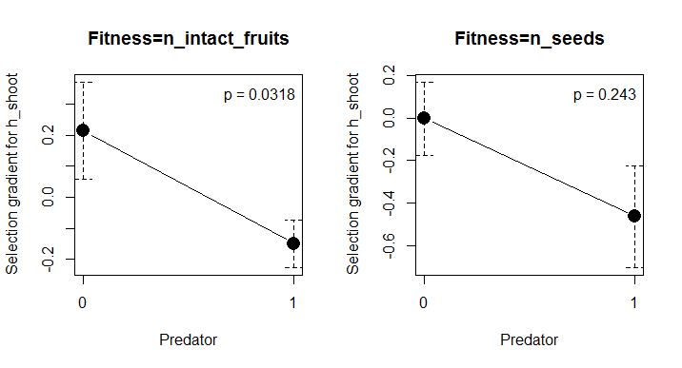

The selection gradients for shoot height were also different between populations with and without predator when fitness was measured as the number of intact fruits. In populations where the predator is absent there was selection for higher shoots, while in populations where the predator was present there was selection for lower shoots. Again, there were no differences when fitness was measured as the number of seeds.

There were not differences in selection gradients for the other traits (flower and shoot number) between populations with and without predator.

**3. Variation in selection gradients with predation intensity**

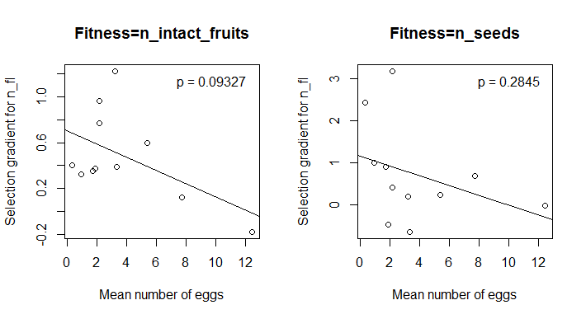

The selection gradient for flower number is now only marginally related to interaction intensity measured as mean number of eggs per population when considering n_intact_fruits as a fitness measure. Populations with higher intensity of predation (higher number of eggs) show selection for lower number of flowers. There is, however, no relation between intensity of predation (measured as mean number of eggs) and selection gradients for phenology, height or number of shoots.

In this year, the relation between intensity of predation measured as mean number of aborted flowers, fruits and buds per population and selection gradient for phenology is not significant. Intensity of predation measured as mean number of predated flowers, fruits and buds did not either show any significant relationship with any of the selection gradients for traits.

**4. Effects of traits on interaction intensity**

Response: n_eggs

Sum Sq Df F value Pr(>F)

phen_index 490.9 1 57.5277 7.578e-14 ***

n_fl 1114.2 1 130.5807 < 2.2e-16 ***

n_shoots 9.9 1 1.1620 0.2813

h_shoot 1.6 1 0.1922 0.6612

LokalID 2576.0 9 33.5433 < 2.2e-16 ***

phen_index:LokalID 797.9 9 10.3902 1.854e-15 ***

n_fl:LokalID 1163.1 9 15.1453 < 2.2e-16 ***

n_shoots:LokalID 74.5 9 0.9700 0.4633

h_shoot:LokalID 48.6 9 0.6326 0.7698

Residuals 8567.1 1004

Response: n_pred_all

Sum Sq Df F value Pr(>F)

phen_index 45.46 1 48.0075 7.417e-12 *** Estimate: 0.23519

n_fl 387.08 1 408.7827 < 2.2e-16 ***

n_shoots 1.36 1 1.4343 0.231328

h_shoot 8.68 1 9.1689 0.002522 ** Estimate: 0.12758

LokalID 163.09 10 17.2228 < 2.2e-16 ***

phen_index:LokalID 6.35 10 0.6702 0.752829

n_fl:LokalID 31.06 10 3.2799 0.000341 ***

n_shoots:LokalID 11.30 10 1.1936 0.290865

h_shoot:LokalID 8.32 10 0.8789 0.552519

Residuals 988.58 1044

Response: n_aborted_all

Sum Sq Df F value Pr(>F)

phen_index 25.07 1 57.2266 8.499e-14 *** Estimate: -0.17248

n_fl 100.96 1 230.4094 < 2.2e-16 ***

n_shoots 0.33 1 0.7609 0.3833

h_shoot 0.29 1 0.6693 0.4135

LokalID 30.79 10 7.0278 9.547e-11 ***

phen_index:LokalID 4.75 10 1.0845 0.3709

n_fl:LokalID 31.85 10 7.2697 3.478e-11 ***

n_shoots:LokalID 6.35 10 1.4491 0.1536

h_shoot:LokalID 6.88 10 1.5698 0.1104

Residuals 457.44 1044

Selection on phenology and flower number seems to be in part determined by the intensity of predation.

The relationship between the number of eggs and phenology and between number of eggs and flower number varied among populations.

The relationship between the number of predated flowers, fruits and buds and flower number varied between populations. However, the relation between the number of predated flowers, fruits and buds and phenology and shoot height was consistent across populations, with more predation in plants flowering early and with higher shoots.

The relationship between number of aborted flowers, fruits and buds and number of flowers varied between populations. The relationship between number of aborted flowers, fruits and buds and phenology was consistent across populations (less abortion in plants flowering early).

B) Using most_adv as a measure of phenology

**2. Differences in selection gradients between populations with/without predator**

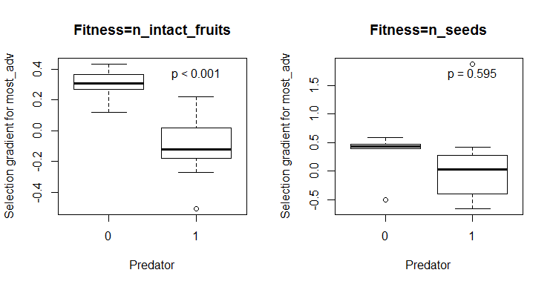

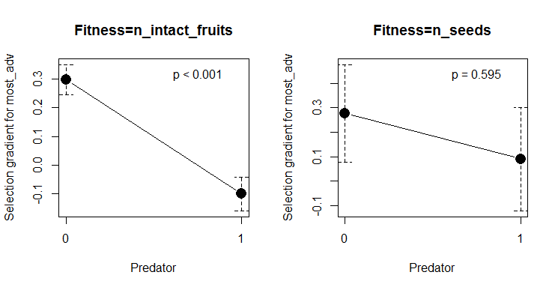

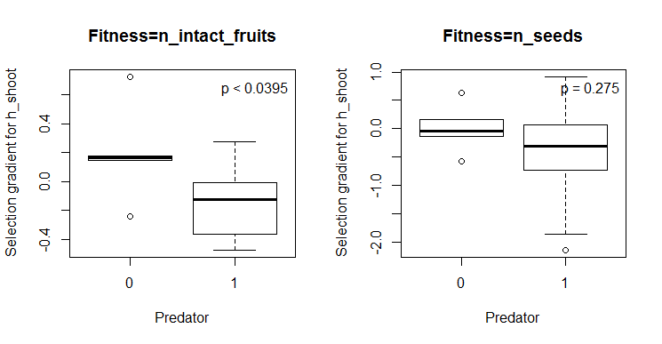

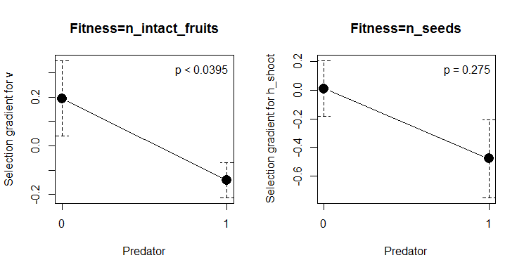

Same results as with phen_index.

**3. Variation in selection gradients with predation intensity**

None of the selection gradients were significantly related to any of the measures of predation intensity in this case.

**4. Effects of traits on interaction intensity**

Response: n_eggs

Sum Sq Df F value Pr(>F)

most_adv 1089.9 1 39.4100 5.029e-10 ***

n_fl 6746.4 1 243.9378 < 2.2e-16 ***

n_shoots 2.1 1 0.0749 0.7844

h_shoot 0.0 1 0.0000 0.9969

LokalID 12722.4 10 46.0021 < 2.2e-16 ***

most_adv:LokalID 1213.9 10 4.3893 4.657e-06 ***

n_fl:LokalID 9014.3 10 32.5943 < 2.2e-16 ***

n_shoots:LokalID 309.3 10 1.1182 0.3448

h_shoot:LokalID 176.7 10 0.6388 0.7812

Residuals 28873.0 1044

Response: n_pred_all

Sum Sq Df F value Pr(>F)

most_adv 24.86 1 25.9725 4.109e-07 *** Estimate: 0.20878

n_fl 267.10 1 279.0652 < 2.2e-16 ***

n_shoots 1.04 1 1.0861 0.29758

h_shoot 8.16 1 8.5240 0.00358 ** Estimate: 0.12371

LokalID 163.03 10 17.0341 < 2.2e-16 ***

most_adv:LokalID 16.30 10 1.7032 0.07528 .

n_fl:LokalID 39.78 10 4.1562 1.170e-05 ***

n_shoots:LokalID 10.94 10 1.1433 0.32615

h_shoot:LokalID 7.47 10 0.7801 0.64815

Residuals 999.22 1044

Response: n_aborted_all

Sum Sq Df F value Pr(>F)

most_adv 7.89 1 17.3898 3.297e-05 *** Estimate: -0.11962

n_fl 100.50 1 221.6308 < 2.2e-16 ***

n_shoots 0.31 1 0.6813 0.4093

h_shoot 0.25 1 0.5483 0.4592

LokalID 30.80 10 6.7930 2.538e-10 ***

most_adv:LokalID 5.99 10 1.3208 0.2140

n_fl:LokalID 33.76 10 7.4445 1.676e-11 ***

n_shoots:LokalID 6.80 10 1.4995 0.1341

h_shoot:LokalID 6.75 10 1.4891 0.1379

Residuals 473.39 1044

**5. Ants 🡨HERE!**

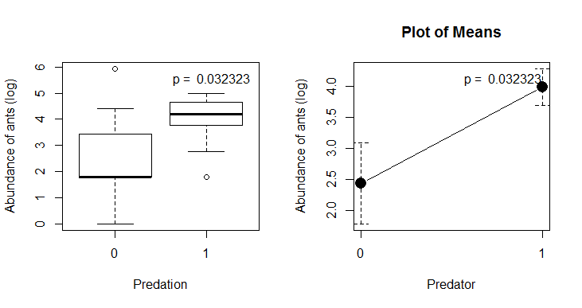

Abundance of ants in both years is strongly correlated. The population Mar001 is still an outlier, with no butterflies but with high number of ants (this population was removed from previous analyses because there were no data on fruits and seeds, but kept here). But in this case the differences between populations with and without predator in ant abundance are significant (using the log of abundance).

If we see it the other way round with a logistic regression, ant abundance has a marginal positive effect on the presence of the butterfly. If we remove the outlier, the effect is fully significant.

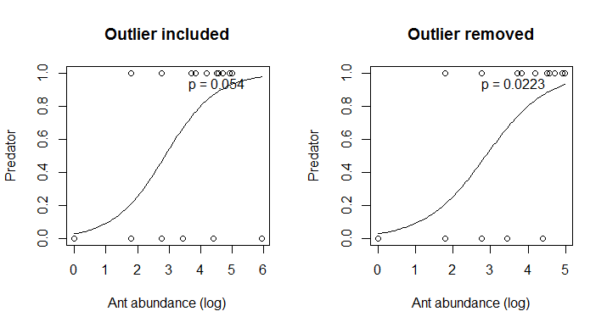

Outlier included:

Call:

glm(formula = pred ~ logants, family = binomial, data = ants)

Deviance Residuals:

Min 1Q Median 3Q Max

-2.1189 -0.8306 0.6591 0.8631 1.5696

Coefficients:

Estimate Std. Error z value Pr(>|z|)

(Intercept) -2.1944 1.3638 -1.609 0.108

logants 0.7298 0.3787 1.927 0.054 .

---

Signif. codes: 0 ‘***’ 0.001 ‘**’ 0.01 ‘*’ 0.05 ‘.’ 0.1 ‘ ’ 1

(Dispersion parameter for binomial family taken to be 1)

Null deviance: 27.526 on 19 degrees of freedom

Residual deviance: 22.499 on 18 degrees of freedom

AIC: 26.499

Number of Fisher Scoring iterations: 4

Outlier removed:

Call:

glm(formula = pred ~ logants, family = binomial, data = ants_sub)

Deviance Residuals:

Min 1Q Median 3Q Max

-2.0123 -0.6817 0.3924 0.6648 1.7740

Coefficients:

Estimate Std. Error z value Pr(>|z|)

(Intercept) -3.5609 1.8337 -1.942 0.0522 .

logants 1.2388 0.5422 2.285 0.0223 *

---

Signif. codes: 0 ‘***’ 0.001 ‘**’ 0.01 ‘*’ 0.05 ‘.’ 0.1 ‘ ’ 1

(Dispersion parameter for binomial family taken to be 1)

Null deviance: 25.864 on 18 degrees of freedom

Residual deviance: 16.685 on 17 degrees of freedom

AIC: 20.685

Number of Fisher Scoring iterations: 5

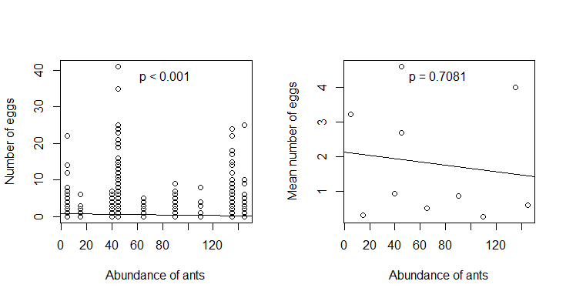

The negative relationship between interaction intensity measured as number of eggs and ant abundance still appears in this year.